MDCJ- 1662-> Resolved
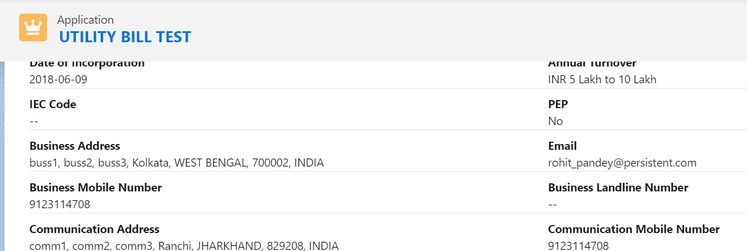

MDCJ- 1716-> Not Resolved
